The AWS Deep Learning AMIs provide machine learning practitioners and researchers with the infrastructure and tools to accelerate deep learning in the cloud, at any scale. One can quickly launch Amazon EC2 instances pre-installed with popular deep learning frameworks and interfaces such as TensorFlow, PyTorch, Apache MXNet, Chainer, Gluon, Horovod, and Keras to train sophisticated, custom AI models, experiment with new algorithms, or to learn new skills and techniques.

Whether you need Amazon EC2 GPU or CPU instances, there is no additional charge for the Deep Learning AMIs – you only pay for the AWS resources needed to store and run your applications.

**Choosing an AWS Deep Learning AMI**

Even for experienced machine learning practitioners, getting started with deep learning can be time consuming and cumbersome. The Amazon Machine Image’s (AMI), offer support the various needs of developers. To help guide you through the getting started process, also visit the AMI selection guide and more deep learning resources.

|  |  |
| --- | --- |
| **CONDA AMI** | **BASE AMI** |
| For developers who want pre-installed pip packages of deep learning frameworks in separate virtual environments, the Conda-based AMI is available in Ubuntu, Amazon Linux and Windows 2016 versions. | For developers who want a clean slate to set up private deep learning engine repositories or custom builds of deep learning engines, the Base AMI is available in Ubuntu and Amazon Linux versions. |

**Recommended GPU Instances**

The following instance types support the DLAMI (Deep Learning AMI). DLAMI instances provide tooling to monitor and optimize your GPU processes.

* Amazon EC2 P3 Instances have up to 8 NVIDIA Tesla V100 GPUs
* Amazon EC2 G3 Instances have up to 4 NVIDIA Tesla M60 GPUs
* Amazon EC2 G4 Instances have up to 4 NVIDIA T4 GPUs
* Amazon EC2 P4 Instances have up to 8 NVIDIA Tesla A100 GPUs

**Cheap Instance to Start Exploring for AIML**

Amazon EC2 G3 instances are the latest generation of Amazon EC2 GPU graphics instances that deliver a powerful combination of CPU, host memory, and GPU capacity. G3 instances are ideal for initial exploration of AIML technologies as they have support for both Linux and Windows.

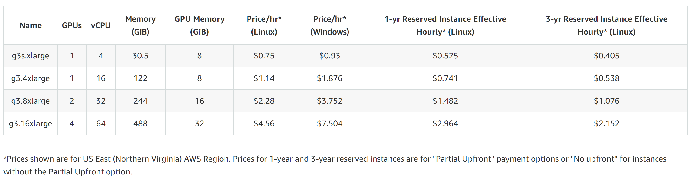

***Fig: Product Details***

**Rough Calculation:**

Operating system - Windows Server

Instances Type - g3s.xlarge

No. of instances - 1 (0.934 USD per g3s.xlarge instance)

EBS Storage Volume (min) - 30 GB (0.10 USD/GB)

Assuming 150 USD [(1* 0.934*150) + (30*0.1*1)] is allocated per associate, then approximately around 155 hours per month can be utilized. Please refer to <https://calculator.aws/#/createCalculator/EC2> for AWS Pricing Calculator.